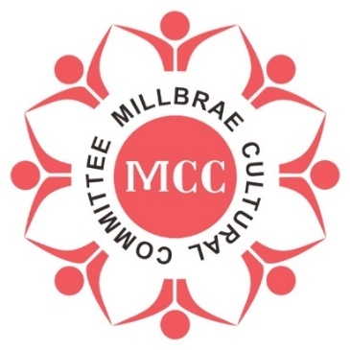 | 4th Lunar New Year Festival  Year of the Rabbit  January 29, 2023  10:30 am – 5:00 pm

Sponsorship Form

Participant Information (please print or type)
 |  | Contact Name |  | Organization
 |  | Address |  | Non-profit 501(C) (3) | YES ___ NO ___
 |  | City
 |  | State
 |  | ZIP Code |  | Telephone
 |  | E-Mail |  | Fax

We are interested in participating in the following area(s) (check box):
SPONSORSHIP  LEVEL |  | Jade Rabbit Sponsorship  (3 booth spaces)  $5000 |  | Gold Festival Sponsorship  (2 booth spaces)*  $3500
Sliver Festival Sponsorship
(1 booth space)*
$2000
****Sponsor is responsible of proper health permit if foods are part of the products at the Festival.****
****Sponsor is responsible of bringing tent, table, and chairs.****
 | Product Description/Special requirements (Please inform us of any special needs/requirements)
 | _________________________________________________________________________________________
I/we, the undersigned participant, parent or guardian, do hereby agree to allow myself or the individuals(s) named herein to participate in the aforementioned activity, and agree to indemnify and hold the Millbrae Cultural Committee and the City of Millbrae and the Millbrae Recreation Department harmless from and against any and all liability for injury which may be suffered by myself or the aforementioned individual(s) arising out of or in any way connected with his/her participating in this activity. I/we further accept full responsibility for any items or articles of clothing which may be lost, damaged or stolen anytime while participating in any activity. In addition, I/we give permission for the Millbrae Cultural Committee and the City of Millbrae to take video/pictures of this event and to use them in any promotional campaigns.
Call 650-684-8097 for Sponsorship information.
Send this form to millbraeculture@gmail.com before December 1, 2022
Please make check payable to:
Millbrae Cultural Committee (non-profit 501(c) (3)) Fed ID: 83-3065681
Signature of Participant: ________________________________________ Date: _____________________
Millbrae Cultural Committee P O BOX 92 Millbrae, CA 94030

