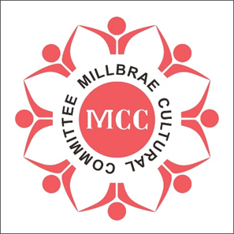 | 4th Lunar New Year Festival  Year of the Rabbit  January 29, 2023  10:30 am

Performance Application Form

Participant Information (please print or type)
 | Contact Name |  | Organization
 | Address |  | Non-profit 501(C) (3) | YES ___ NO ___
 | City
 | State
 | ZIP Code |  | Telephone
 | E-Mail |  | Fax
Performance Group: _______________________________________
Director(s) : _______________________________________

Performance number 1:
Title: | Length in minute:
Description:

Performance number 2:
Title: | Length in minute:
Description:

Special requirements _______________________________________________

I/we, the undersigned participant, parent or guardian, do hereby agree to allow myself or the individuals(s) named herein to participate in the aforementioned activity, and agree to indemnify and hold the Millbrae Cultural Committee and the City of Millbrae and the Millbrae Recreation Department harmless from and against any and all liability for injury which may be suffered by myself or the aforementioned individual(s) arising out of or in any way connected with his/her participating in this activity. I/we further accept full responsibility for any items or articles of clothing which may be lost, damaged or stolen anytime while participating in any activity. In addition, I/we give permission for the Millbrae Cultural Committee and the City of Millbrae to take video/pictures of this event and to use them in any promotional campaigns.
Call 650-684-8097 (Nienhwa) for Performance information.
Send this form to millbraeculture@gmail.com before December 20, 2022
Signature of Participant: ________________________________________ Date: _____________________

